Unit 6: Sampling Distribution of the Mean & Central Limit Theorem

Why This Matters for Computing

The Central Limit Theorem (CLT) is one of the most important concepts in statistics and computing. Understanding it enables you to:
- Build confidence intervals for performance metrics (API response times, database query latency)
- Understand Monte Carlo simulations and bootstrapping techniques
- Make predictions about system behavior under load

Law of Large Numbers

As the sample size increases, the sample mean converges to the population mean.
Mathematical statement: If $X₁, X₂, ..., Xₙ$are independent random variables with mean$μ$, then as$n → ∞$, the sample mean $\overline{x} → μ$

Example: You run a search algorithm 10 times and get an average execution time of 152ms. Run it 1000 times, and the average stabilizes around 145ms. Run it 100,000 times, and it converges to 144.7ms (the true mean).

Key Insight: More data gives you a better estimate of the true average but tells you nothing about the shape of the distribution of sample means.

Sampling Distribution of the Mean

Definition: The distribution of sample means obtained from repeated sampling from the same population.

A thought experiment:
1. Take a random sample of size n from a population
2. Calculate the sample mean X̄
3. Repeat this process many times
4. Plot a histogram of all those sample means
That histogram is the sampling distribution of the mean.

Properties

Mean of the sampling distribution: $μ_{\bar{X}} = μ$ (same as population mean)
Standard deviation of the sampling distribution (Standard Error):$SE = \frac{σ}{\sqrt{n}}$
Notice: As sample size n increases, the standard error decreases. Sample means vary less than individual observations.

Central Limit Theorem

Statement: For a population with mean μ and standard deviation σ, the sampling distribution of the mean approaches a normal distribution as sample size n increases,
regardless of the shape of the population distribution.
Mathematically: $\overline{X̄} \sim N(μ,\frac{σ}{\sqrt{n}}$) for large n

Why This Is Remarkable
The population distribution can be anything – heavily skewed, bimodal, uniform, discrete – but the distribution of sample means will still be approximately normal if n is large enough.

When Does CLT Apply?

Rule of thumb: n ≥ 30 usually sufficient for most distributions
Symmetric distributions: n ≥ 15 may be enough
Highly skewed distributions: n ≥ 100 may be needed
Already normal: Any n works

When CLT Doesn't Apply

• Heavy-tailed distributions may require extremely large n or not converge at all
• Non-independent observations (time series with autocorrelation)
• Finite population sampling without replacement (requires finite population correction)

Standard Deviation vs Standard Error
This distinction may confuse us but is crucial:
Measure | Standard Deviation $(σ or S)$ | Standard Error (SE)
What it measures | Variability of individual observations | Variability of sample means
Formula | σ (population) or  S$= \sqrt{\left[\frac{Σ{\left(xᵢ - \bar{x}\right)}^{2}}{\left(n-1\right)}\right]}$ | $$SE =\frac{ σ}{\sqrt{n}} or \frac{ S}{\sqrt{n}}$$
Effect of sample size | Stays roughly constant (property of population) | Decreases as n increases
Example | API response times vary by 50ms (SD) | Average of 100 measurements varies by 5ms (SE = $\frac{50}{\sqrt{100}}=5$ ms)

Problem 1: A database query has mean execution time 24ms with SD 8ms. You measure the average time over 64 queries. What is the probability that your average is greater than 26ms?

Problem 2: Assume that the population of male BCIT students has normally distributed weights, with mean 173.2 lb and a standard deviation of 29.5 lb.
- Find the probability that if a male student is randomly selected, his weight is greater than 200 lb.

- An elevator has a maximum weight capacity of 7200 lbs. Find the probability that 36 randomly selected male students will exceed the elevator’s weight capacity.

Problem 3: Example: You're optimizing an e-commerce website. Individual page load times are highly variable and right-skewed:
• Most pages load in 200-400ms
• Some take 500-800ms (large images)
• Occasional spikes to 2000ms+ (network issues, database queries)
• Population mean: μ = 350ms, population SD: σ = 180ms
Describe the sampling distribution of the mean
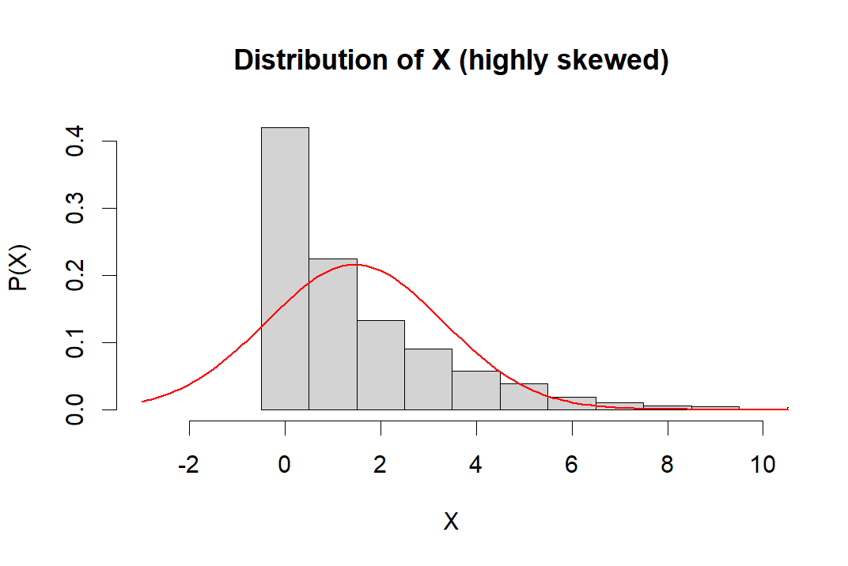

Central Limit Theorem for Proportions

If we take random samples of size n from a population with proportion p, then as the sample size becomes large, the sampling distribution of the sample proportion p̂ will be approximately normally distributed with:
Mean: $μ_{\hat{p}} = p$
Standard Error: $σ_{\hat{p}} = \sqrt{\left[\frac{p\left(1-p\right)}{n}\right]}$
Conditions for Normal Approximation:
The normal approximation is appropriate when:
$$np ≥ 10 and n(1-p) ≥ 10$$

These conditions ensure we have enough "successes" and "failures" in our sample for the normal approximation to be valid.
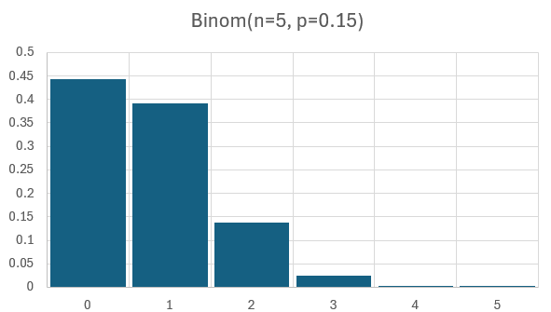 | 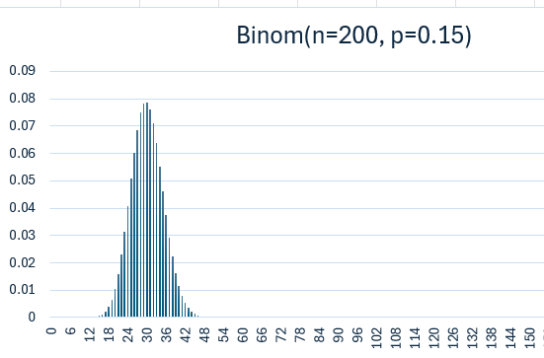

Problem 3: A factory claims 95% of products pass quality inspection (p = 0.95). You sample 200 products and find that 185 passed. Is this unusually low?

Problem 4: A lifestyle influencer claims that 72% of their followers are "highly engaged" (they like, comment, or share at least once per week). A marketing agency considering a partnership randomly samples 300 of the influencer's followers to verify this claim. In their sample, they find that 204 followers are highly engaged.
Questions:
a) What is the sample proportion$p̂$ of highly engaged followers?
b) Assuming the influencer's claim is true ($p = 0.72$), what is the mean and standard error of the sampling distribution of sample proportions?
c) Verify that the conditions for using the normal approximation are satisfied.
d) What is the probability of observing a sample proportion of 68% or less if the influencer's claim is true?
e) Based on your answer to part (d), does the sample evidence support or contradict the influencer's claim? Explain briefly.

Problem 5: How many measurements do you need to reduce the standard error to 10% of the population standard deviation?

Common Mistakes to Avoid:

Forgetting to check conditions - Always verify np ≥ 10 and n(1-p) ≥ 10 before using normal approximation
Using p̂ in the standard error formula - Always use the claimed population proportion p in $σ_{\hat{p}} = \sqrt{\left[\frac{p\left(1-p\right)}{n}\right]}$, NOT the sample proportion $p̂$
Confusing p with $p̂ with p$:
$p$ is the true population proportion (often claimed or hypothesized), while $p̂$ is what you observe in your sample
Wrong formula: Don't use $\frac{σ}{\sqrt{n}}$ (that's for means!). For proportions, use $\sqrt{\left[\frac{p\left(1-p\right)}{n}\right]}$

The Formula in Context:
Component | Meaning | Business Translation
$$p$$ | True population proportion | The real rate/percentage in the entire population
$$p̂$$ | Sample proportion | What you actually observed in your sample
$$n$$ | Sample size | How many observations you collected
$$μ_{p̂} = p$$ | Mean of sampling distribution | Sample proportions center around the true proportion
$$σ_{\hat{p}} = \sqrt{\left[\frac{p\left(1-p\right)}{n}\right]}$$ | Standard error | How much sample proportions typically vary

In making this document, have used Claude.ai Sonnet 4.5 to structure, edit, and create computing related examples.

